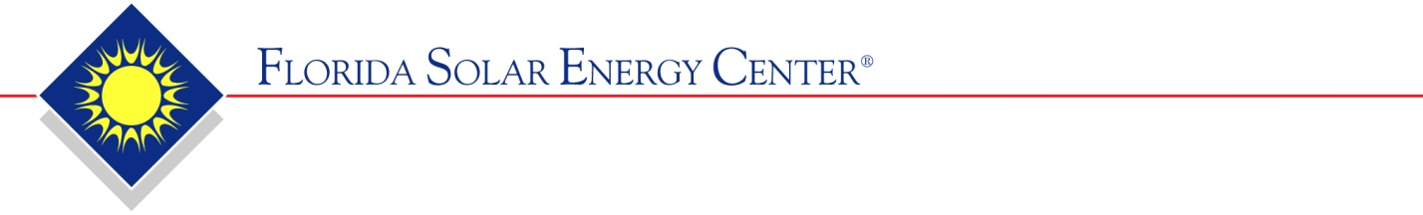

1679 Clearlake Road • Cocoa, FL 32922-5703 • (321)638-1711 • Fax: (321)638-1010
APPLICATION FOR SOLAR COLLECTOR CERTIFICATION
VIA PRIVATE LABEL

NOTE: SEPARATE APPLICATIONS MUST BE SUBMITTED FOR EACH COLLECTOR MODEL

Name of company currently holding the certification:
FSEC Number of collector already certified:
Model Name of collector already certified:

NAME OF NEW COMPANY:
ADDRESS:
CITY: | STATE: | ZIP:
PHONE NUMBER: | CONTACT PERSON:
WEB SITE:
FAX NUMBER: | E-MAIL:
TOLL FREE NUMBER:
COLLECTOR MODEL NUMBER:
COLLECTOR BRAND/TRADE NAME:
“The information submitted with this application has been reviewed by me and is true and correct to the best of my knowledge and belief.”

NAME (printed):

SIGNATURE:

TITLE:

DATE:
PRIVATE LABEL APPLICATION ATTACHMENTS

The following items must be submitted:

- Copy of the product warranty
- Copy of the installation, operation, and maintenance manuals
- Letter from the company currently holding the certification authorizing the new company to private label the certification.

